Name : - Ankit Chawla
Roll No :- 224050
Course :- BSc. (Hons.) Computer Science

Question :-
Create a Flutter App
- To display text in
- Different font size
- Different colors
- Different spacing and styles
Create a Flutter App
- To display Icon on home page with
- Different size
- Different colors
- Text

Code :-
Part 1
import 'dart:ui';
import 'package:flutter/material.dart';
void main()
{
runApp(const MyApp());
}
class MyApp extends StatelessWidget
{
const MyApp({super.key});
@override
Widget build(BuildContext context)
{
return MaterialApp(
//Scaffold Widget
home: Scaffold(appBar: AppBar(
title: const Text ('GFG')),
body: const Center(child: Text('Hello Guyss!!',textAlign: TextAlign.center,style:TextStyle(fontSize: 50,color: Colors.yellow,fontStyle: FontStyle.italic,letterSpacing: 8,wordSpacing: 20)),
// body: const Center(child: Icon(Icons.account_circle,size: 170,color: Colors.blue)),
),));
}
}

Part 2
import 'dart:ui';
import 'package:flutter/material.dart';
void main()
{
runApp(const MyApp());
}
class MyApp extends StatelessWidget
{
const MyApp({super.key});
@override
Widget build(BuildContext context)
{
return MaterialApp(
//Scaffold Widget
home: Scaffold(appBar: AppBar(
title: const Text ('GFG')),
// body: const Center(child: Text('Hello Guyss!!',textAlign: TextAlign.center,style:TextStyle(fontSize: 50,color: Colors.yellow,fontStyle: FontStyle.italic,letterSpacing: 8,wordSpacing: 20)),
body: const Center(child: Icon(Icons.account_circle,size: 170,color: Colors.blue)),
),);
}
}

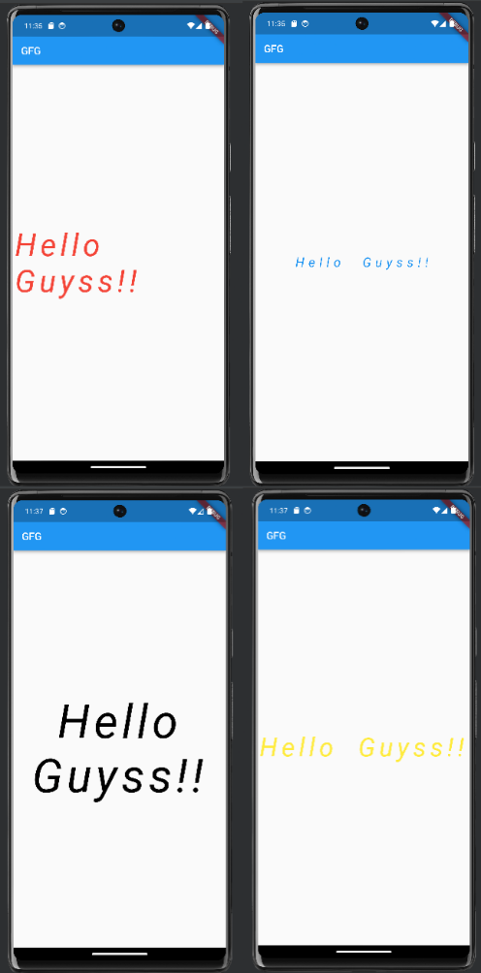
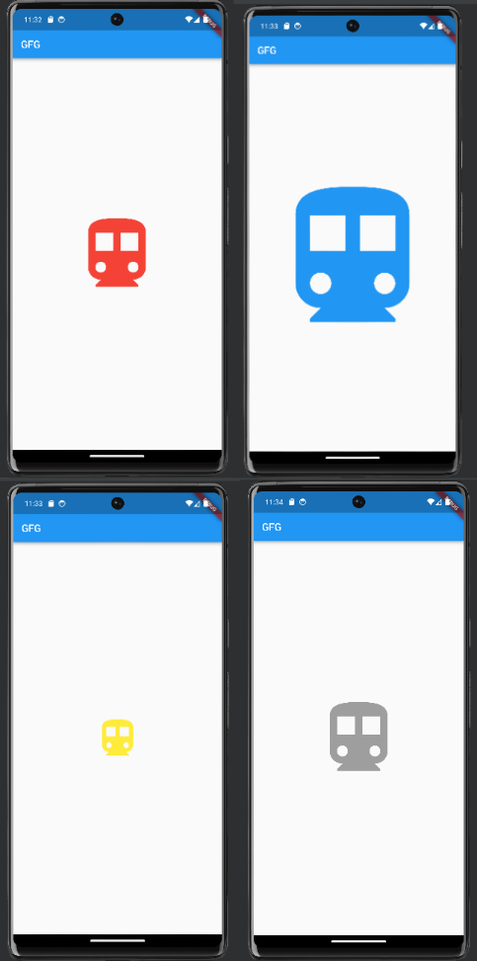
Output :

